New customer application with a valid VIN that is Title Releasable. The loan was booked and the funding failed at the last step of the process

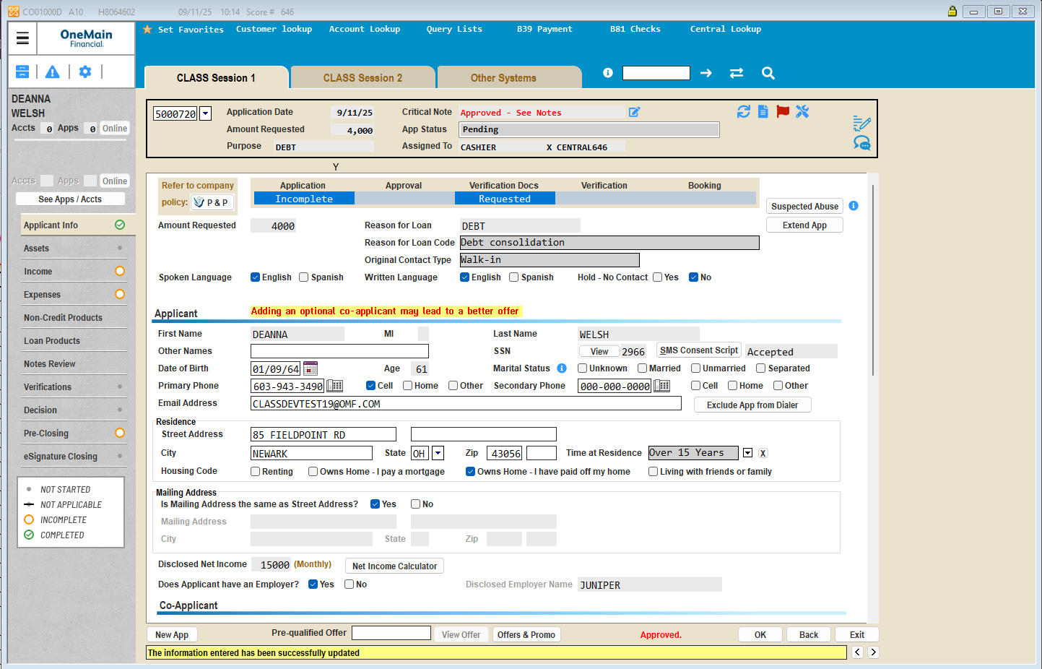

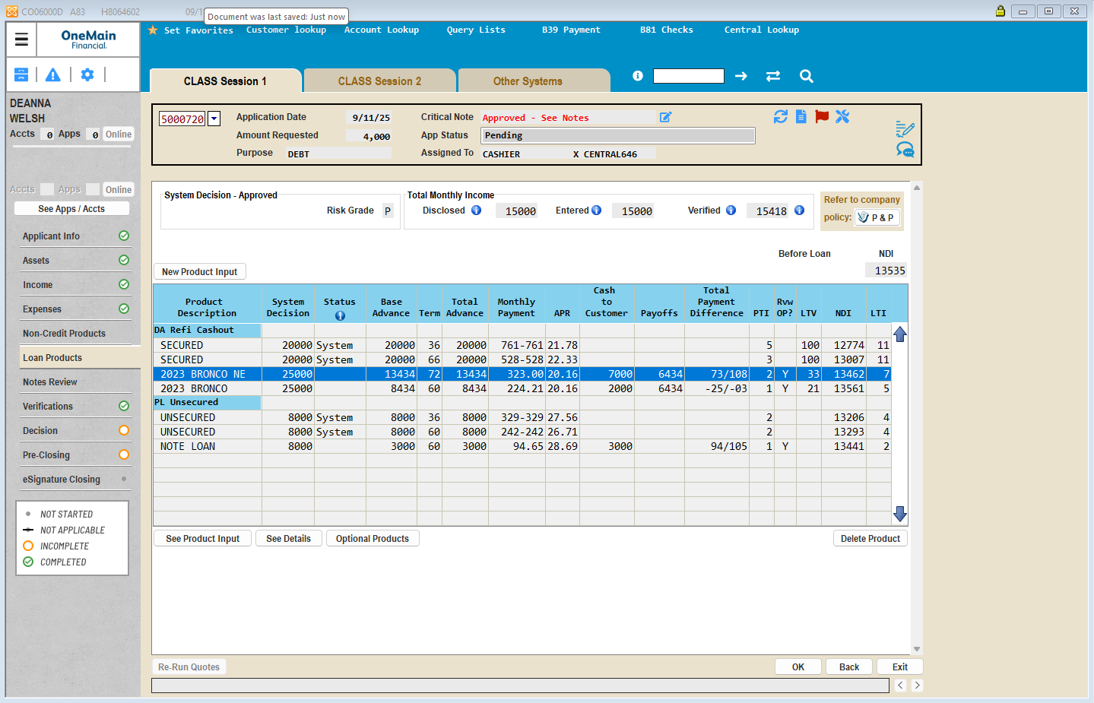





Issue with Funding – please see record for Application_N = 5000720

Reason that funding failed is below:

There is a mismatch in data area EPQTRDTA in ICEINT01for the row corresponding to ATFUND, the program name to call is wrong.

Having this value is causing jobs ATFUND_01 and ATFUND_02 to skip processing Accelerated Title funding as the parameters in the program call and the program being called are not matching

